Year 13 NEA

To what extent is Mermaid Quay a Fortress Landscape?

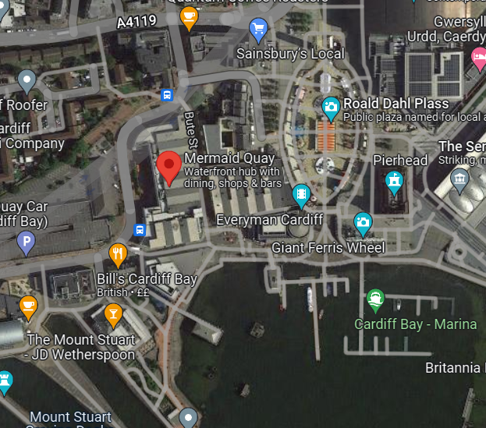

Figure - Map of Mermaid Quay (Google Maps. n.d.) 10:11

Joshua Netherton

Cleeve Sixth Form Centre of Excellence

Year 13 NEA

Contents

Introduction 2

Hypothesis 2

Specification Link 2

Theory and Research 2

Hypothesis Breakdown 5

1. Crime in Mermaid Quay occurs prevalently. 5

2. Evidence of major fortification of Mermaid Quay is present. 6

3. Distribution of fortification is widely spread and even throughout Mermaid Quay. 7

Methodologies 8

Risk Assessment 9

Crime in Mermaid Quay occurs prevalently 9

Evidence of major fortification of Mermaid Quay is present 10

Distribution of fortification is widely spread and even throughout Mermaid Quay 12

Data Representation and Analysis 13

Crime in Mermaid Quay occurs prevalently 13

Evidence of major fortification of Mermaid Quay is present 19

Distribution of fortification is widely spread and even throughout Mermaid Quay 21

Land Use Survey 22

Conclusion 23

Hypothesis Breakdown 23

1. Crime in Mermaid Quay occurs prevalently. 23

2. Evidence of major fortification of Mermaid Quay is present. 23

3. Distribution of fortification is widely spread and even throughout Mermaid Quay. 23

To what extent is Mermaid Quay a Fortress Landscape? 24

Evaluation 25

Table of Figures 26

Bibliography 27

# Introduction

## Hypothesis

I have three hypotheses that will answer my main question. They are:

1. Crime in Mermaid Quay occurs prevalently.
2. Evidence of major fortification of Mermaid Quay is present.
3. Distribution of fortification is widely spread and even throughout Mermaid Quay.

## Specification Link

Throughout this document links will be made to the subject specification, which is AQA A-Level geography. The work I am doing will come from a certain section of the course I am studying and will typically link to more than once section. My investigation title is “To what extend is Mermaid Quay a fortress landscape?” This ties into primarily section 3.2.1.1 Globalisation and 3.2.3.2 Urban forms. Here we can investigate how Mermaid Quay is developed as a Fortress Landscape while serving its purpose as a shopping centre in the Cardiff Bay area.

My title links to multiple sections of the course. 3.2.1.1 is Globalisation and in a world ever expanding and growing, in terms of both population and security, fortress landscapes are both changing and growing ever more prevalent. Section 3.2.3.2 is Urban Forms, and different ways of fortifying links to this section. In Section 3.2.2.1 which is the nature and importance of place allows me to look at why somewhere like Mermaid Quay would be fortified.

Finally, the skills I will use to collect data links to Section 3.2.2.3, where I will use both numerical and worded sources of data to answer my sub-questions.

## Theory and Research

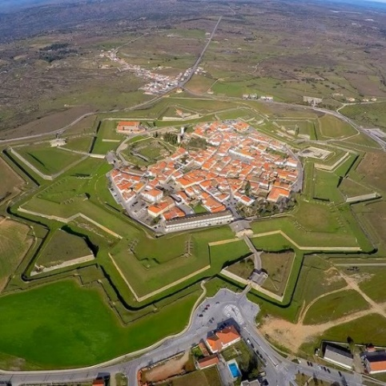Fortress Landscapes are deliberately landscaped and designed around security, protection, surveillance, and exclusion. [1] More prevalent in medieval era constructions you can visually see the defences in place, such as walls and moats, along with typical construction taking place at strategic high points with good visibility. These methods are done with the intent to provide the most security and safety to the inhabitants of the facility.

In the modern era it is less prevalent to see such blatant techniques, however, this isn’t to say methods aren’t still used that line up with the continued existence of fortress landscapes. Features such as CCTV (Closed Circuit Television), security alarms, gated communities, and speed bumps are all day-to-day features of towns and cities designed to protect and seclude residents.

Figure - Sky view of fortress (Atlas Obscura, n.d.) 10:01

One controversial fortress landscape more prevalent in modern day cities is anti-homelessness architecture. This is defensive architecture, hostile designs, or exclusionary designs [2] with the intention of preventing homeless people from residing in public spaces. There is a stigma of crime and unsafe behaviour surrounding homeless populations in cities and so city designers are including items such spikes, or contoured designs of benches to prevent the stay of homeless people. This will reduce the number of lingering people, but some see it as inhumane and cruel, considering how much they are already struggling, it 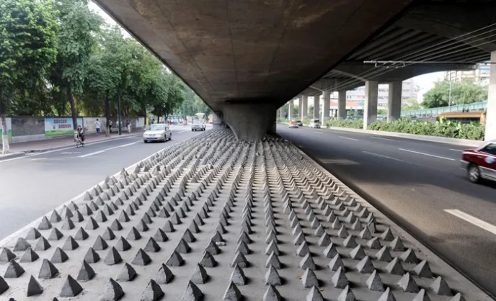isn’t fair to do this on top of that. Mosquito Alarms[3] provide a similar purpose by letting of a high-pitched squeal outside shops to disperse crowds and people are more on board with this, however, this is more designed for temporary crowds with somewhere to go. Anti-homeless architecture is designed to kick people out with nowhere else to go, hence its controversy.

Figure - Anti-homeless architecture (Andreou, 2015) 10:52

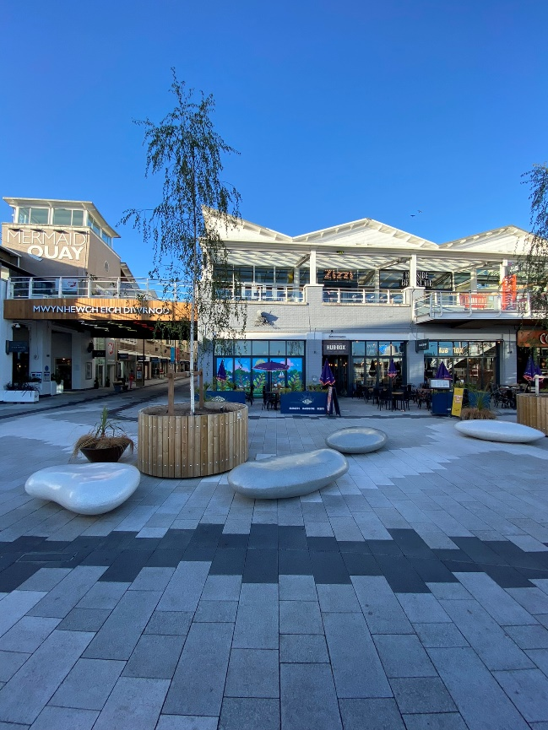We can see another example of this in Figure 4, where the seating has been designed to prevent sleeping on by taking a curved design to resemble rocks. Whether this is intentional it is unclear, however, this design does result in no homeless people residing in this spot here in Mermaid Quay.

This is one of many features of a Fortress Landscape present in Mermaid Quay, and my research will investigate what else is present in this area to maintain safety and security. Designed as a seaside shopping spot in a once run-down area of Cardiff Bay. It has been significantly redeveloped and a large part of that – similar to many modern cities – has been ensuring safety and security is present and maintained but a larger part for Mermaid Quay has been ensuring that the look and feel of the area has not been tainted by features designed for this purpose. In Figure 3 the spikes could be considered an eye soar, not pleasant to look at and unfriendly for pedestrians passing by. Mermaid Quay’s approach is a much more appealing approach to preventing homeless people from sleeping in this area.

Figure - Anti-homeless architecture in Mermaid Quay (Netherton, 2022a)

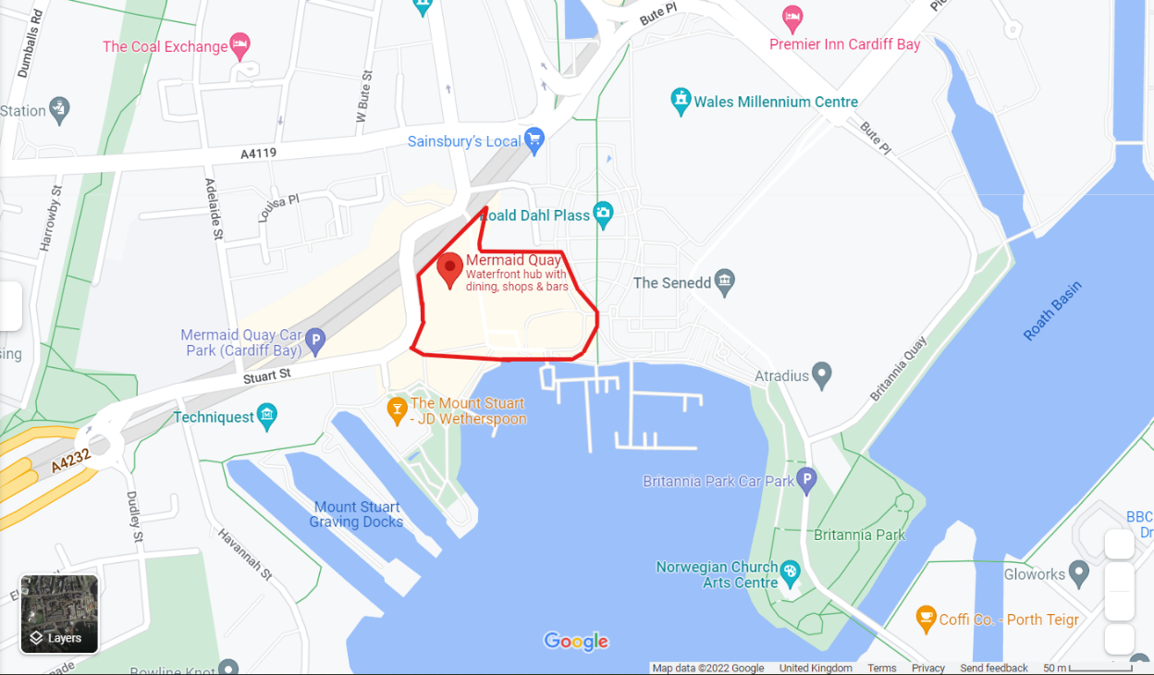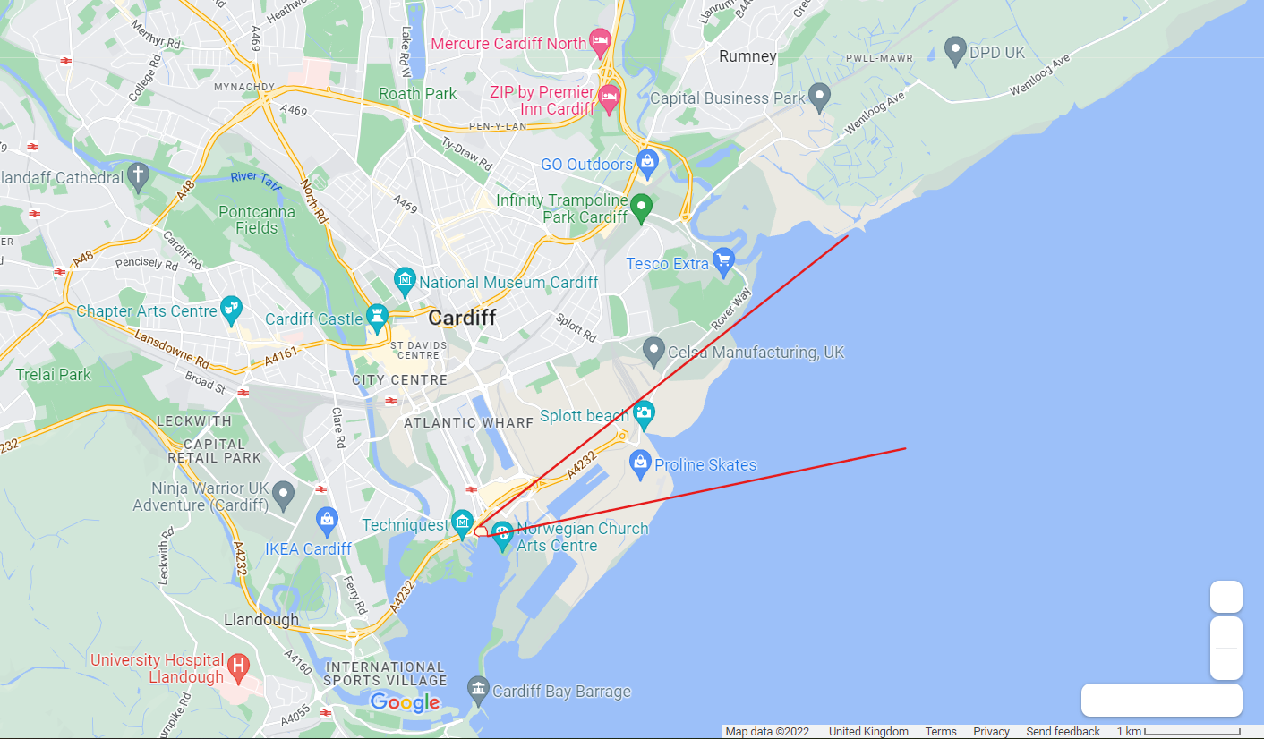

Figure - Highlight of Mermaid Quay (Mermaid Quay · Cardiff CF10 5BZ, UK, n.d.) 11:04

Figure - Map of Cardiff (Mermaid Quay · Cardiff CF10 5BZ, UK, n.d.) 11:04

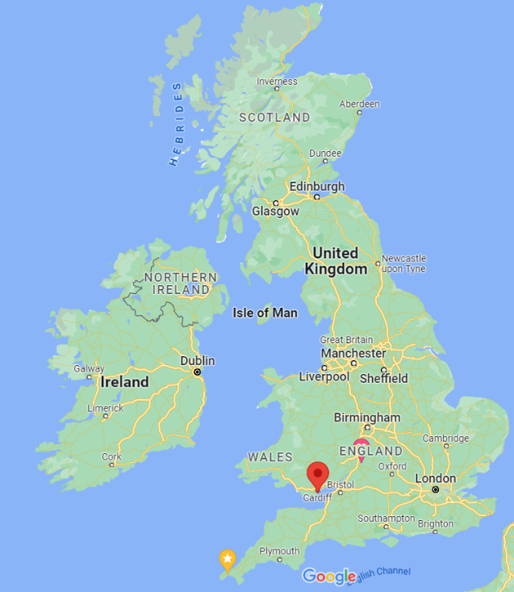 Mermaid Quay is in Cardiff Bay, in the south of Cardiff City. It is based within the bay area, and by extension is protected by the Cardiff Bay Barrage. Accessible by both road and pedestrian only routes it is easy to access and get to for the majority of people and services.

 Cardiff is found on the South coast of Wales along the Bristol Channel. Once a major exporter of minerals such as coal and iron, following its deindustrialisation throughout 1971-2015 [4] this area is no longer used for industry like it used to be. For a time, Cardiff was a highly industrial export port for the Welsh mineral trade. However, as this industry declined so did the quality of the coastal area. For a time, the area behind the Cardiff Bay Barrage was mud and silt that smelt bad and made this an extremely unattractive place to be. Major regeneration took place in 2000 [5] and this worked on remaking an old dry dock and part of this was also the building of the modern-day Mermaid Bay.

Figure - Map of United Kingdom (Google Maps, n.d.) 11:15

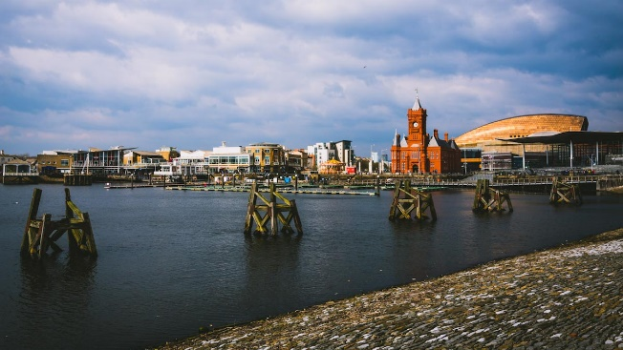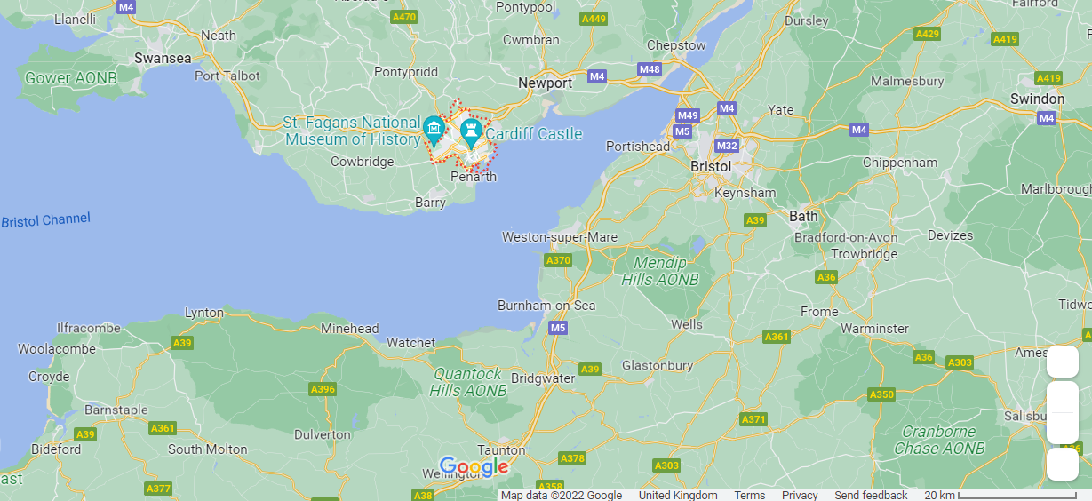Cardiff is located on the south coast of Wales, west of Newport and east of Swansea. It has a railway station, Cardiff Central, along with some of its own internal stations which allow for better connectivity throughout the city. The M4 and the A470 both run through Cardiff allowing for excellent connection with the rest of the country. This also means that nearby towns and villages are able to easily commute into the city. With its proximity to other cities and the ease of connectivity between them, this also permits excellent trade routes and connections between these cities promoting job opportunities and the further share of culture.

Figure - Place map for Cardiff (Cardiff · United Kingdom, n.d.) 12:46

As mentioned, Cardiff Bay has seen development throughout recent years. This development has been fuelled by local Urban Development Corporations. These are any several former organisations started by the government to develop and improve areas of the inner city. [6] In Cardiff, the Cardiff Bay Development Corporation (CBDC) formed on the 3rd of April 1987 has worked to improve this area. Covering an area of about 1,089 hectares. Mermaid Quay is a stronghold of shops and would’ve been one of the focuses of this redevelopment, as attracting tourists and businesses to an area is the best way to fuel the local economy and start a chain reaction of more money, more development, more money, and so on. This development corporation split Cardiff Bay into 9 sections, and Mermaid Quay would be in the inner harbour section. (Information taken from)[7]

Figure - Cardiff Bay (Kieren, n.d.) 11:50

## Hypothesis Breakdown

### Crime in Mermaid Quay occurs prevalently.

Fortification of places occurs with the intent of increasing safety and reducing crime in a place. Simply, a place may have high rates of crime and so it fortifies, or it may fortify to start with to prevent crime from taking place in the first place. An example of the former is a castle. These are built on empty ground with many different defensive features in place to protect it. Crime wasn’t necessarily taking place in that spot prior to construction, but in 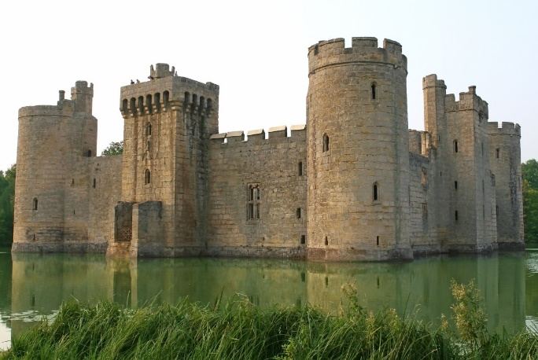anticipation of potential attacks, features have been included. In medieval construction, fortress features do differ to modern day techniques, but the concept behind them are the same.

Figure - Fortress example (Eaglescliffe, 2014) 13:14

This can be seen in the modern day when new buildings are built with state-of-the-art surveillance and security, new techniques, but a method that dates back hundreds of years. Some places however take a different approach. Whether the methods used are now out of date, or none were used in the first place, sometimes places and buildings need to update their fortress features due to more crime taking place. Somewhere once relatively safe may start seeing increased rate of crime – especially if their methods of defence have become out of date.

Mermaid Quay takes on both approaches. Opening in 1990 and seeing major regeneration since [8] this hypothesis states that crime in this area has increased. My following hypothesis state that fortification has taken place, and with this I am predicting that this is a result of increased or continued crime in the area. It has undergone regeneration and with this more security features have been introduced, and I want this hypothesis to uncover why this has happened.

### Evidence of major fortification of Mermaid Quay is present.

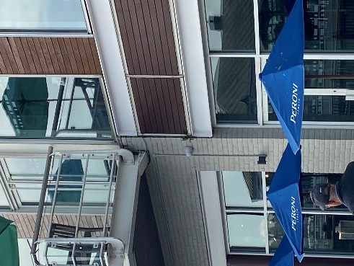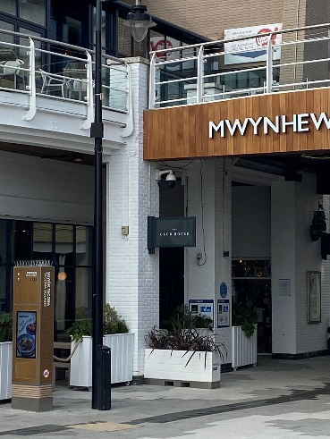For Mermaid Quay to be considered a fortress landscape major fortification will need to have taken place. Features and development will need to be in this area in many forms, however, to maintain a friendly and welcoming feeling these features cannot be too prevalent or intrusive, or it may ward visitors off. The Big Brother concept is a synonym for abuse of government power, particularly in respect to civil liberties, often specifically related to mass surveillance and a lack of choice in society.[9] In essence it is the idea of constant surveillance by the government, with the idea of keeping people safe, but is taken too far and people begin to lose their sense of privacy.

Figure - CCTV Features in Mermaid Quay (Netherton, 2022b)

One thing that developers need to be careful of when fortifying a landscape is taking their methods too far and creating this “Big Brother” feeling in a place. There is a fine line between monitoring somewhere to keep it safe, and intrusive surveillance that undoes the job it is trying to do. As seen in Figure 10, Mermaid Quay possesses CCTV throughout and has both public and private surveillance taking place. Bristol council will monitor Mermaid Quay, but also private businesses will monitor their own property and assets.

Having visited Mermaid Quay I don’t feel that the security measures in place where overbearing or intrusive, but it was clear there was surveillance taking place more so than other areas of Cardiff Bay. This hypothesis is that major fortification has taken place in this area, and using methods outlined in the next section I intend to prove that this is true, and that the methods are adequate for the needs of Mermaid Quay.

### Distribution of fortification is widely spread and even throughout Mermaid Quay.

When developing a place sometimes this development can be uneven and areas which get more funding may see further features implemented. This can happen for many reasons, but typically a divide in finances or funding can result in some areas getting better development than others. Typically, the crime rates reflect this as well. Tending to be higher in the areas with less funding, due to less policing and methods of mitigation.

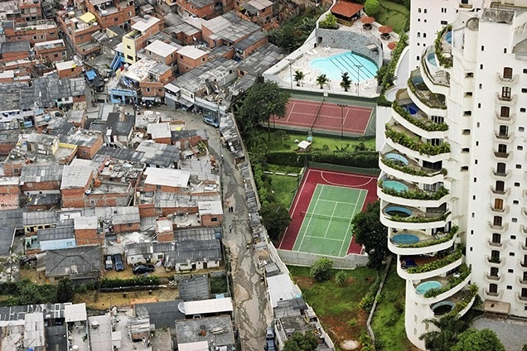Sometimes, this can occur with no issue, one place has more fortress development because it needs it, and somewhere else doesn’t have as much because it doesn’t need it. In this case, there is nothing bad about this. Adding CCTV – among other features – to somewhere that doesn’t need it can contribute to that “Big Brother” culture, and so it is best to leave it.

As can be seen in Figure 11, São Paulo is an excellent example of how uneven development can occur on a large scale. Poverty right next to wealth with nothing more than a wall dividing them. This in itself can be considered a fortress landscape, the wealthier side, with a focus on making sure the residents are safe.

Figure - Uneven development in São Paulo (Catling, 2015) 11:06

As development of Mermaid Quay has happened, it is clear that it has been relatively even throughout, and so I believe by extension the development of security features has been even too. It isn’t a large enough area for certain spots to be of a higher security than the rest of Mermaid Quay and any funding would be reserved for the entire area. The only exception I believe may occur is when private businesses implement their own security features for their businesses, this may result in shops being more heavily defended than the rest of the area. My research will prove than in general, the defences in place will be evenly spread and no one area will have been focused on more than the rest.

# Methodologies

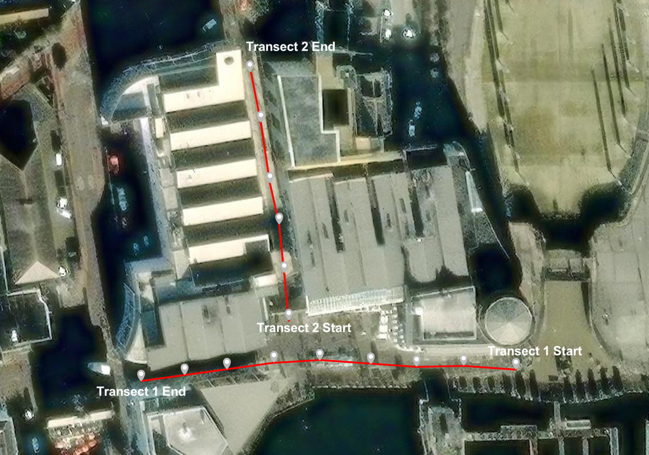 My data collection was done in the months of October and November 2022 in Mermaid Quay, Cardiff. To prove my hypothesis, I will complete two transects of the Quay, collecting data about security features I can see from points along my transect, one was completed on Thursday 20th October 2022 between 16:00 to 17:00, and one will be completed on Saturday 19th November 2022 between 14:00 and 15:00. I will also complete surveys, these will have no transect or order, I will randomly select people in the crowd, this will only be done on the 19th of November. To prove my hypothesis, I will also be using secondary data which I will collect online. I had tentatively planned on questioning someone on each point of my transect, but this glued me to one point, and it was easier to approach people wherever they were at the time. This method is a systematic approach.

Figure - (www.arcgis.com, n.d.) 18:19

Figure 13 is a map of the transects where I have counted the security features from. Each point is approximately 20 paces from each other, with one going East to West (9 points), and the other going South to North (6 points). It was from these points I had planned on doing my survey from too, but upon being there I decided against this idea due to difficulties with approaching people while remaining at that point, and instead randomly selected people in the area to question. This is a random sampling method.

For further data, I will also be using secondary data which I will access primarily through the internet.

## Risk Assessment

|  |  |  |  |
| --- | --- | --- | --- |
| Hazard? | Who is at risk? | Risk rating out of 5? (5 = High Risk) | What will be done? |
| Sunburn | Accomplices and I | 2 | Ensure suncream is applied if sunny, appropriate clothing is worn. |
| Trips and falls | Accomplices and I | 4 | Ensure appropriate footwear is worn. |
| Hit by car | Accomplices and I | 4 | Ensure road crossings are done at designated crossing points, and checks are made before stepping out. |
| Overly cold | Accomplices and I | 3 | Ensure appropriate clothing is worn. |
| Hostile/Aggressive Individuals | Accomplices and I | 2 | Ensure vigilance and appropriate judgement is used when approaching members of public. |
| Asthma | Myself | 2 | Ensure inhalers are brought with and readily accessible. |
| Unhygienic pavement hazards (Dog poo/sick) | Accomplices and I | 4 | Be vigilant when walking on pavement. |
| Hit by bike/e-scooters/other on pavement vehicles | Accomplices and I | 4 | Be vigilant when walking on pavement. |

Figure - Risk Assessment

## Crime in Mermaid Quay occurs prevalently

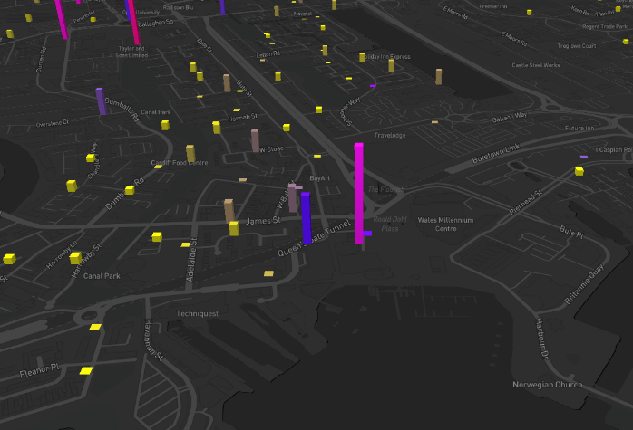 To decide whether crime in Mermaid Quay is prevalent, I will primarily be using secondary data. To answer this using primary, I would need to watch this area, for prolonged periods of time over multiple days, something I do not have the option of doing. There would be no way to accurately represent whether this is true using the two short days I will have spent in this area, as either one or both could easily be an anomaly, and I would not see much of the day – such as evening time – with the hours I am spending there.

As a result of this, I have elected to use secondary data to help prove this hypothesis. Using Street Check [10], and CrimeRate [11] I will look at how much crime is currently taking place in this area. CrimeRate 12 is a fantastic online resource which allows me to look at a map with bars over each area of Cardiff, which tell me exactly what crime takes place there, and allows me to compare it to the rest of Cardiff. I will direct my attention to Mermaid Quay and look at what happens there, comparing this to surrounding areas to see if crime is frequent or not. One drawback of some online resources is it can be tricky to look at crime rates specifically in Mermaid Quay. This will provide some insight into my hypothesis, however, may leave some aspects of my response less specific than I had hoped.

Figure - CrimeRate map (crimerate.co.uk, n.d.) 16:03

Once I have this information, I will lay it out in the form of pie charts, with each section containing a different type of crime which has taken place, and once I am able to show how much crime is taking place, this will tell me whether crime is or is not prevalent in Mermaid Quay. This method is best as it shows a very clear comparison of the proportion of different crimes and their severity in one area. I will also use a bar chart, which will allow me to show how many crimes take place over a larger, more simplified area. While pie charts are a good way to show proportions, they can sometimes be difficult to read, especially for small segments.

I will also use a scatter graph. It is an excellent way of showing change of something over time. A pie chat would be a horrible way as it condenses the data down far too small for the time scale of the data I am looking to represent. It is also a good way of letting me display anomalies and when the trend is higher or lower than average.

Along with this, I will be using some primary data in the form of surveys from 14:00 to 15:00 on Thursday 20th November 2022. This will be done in the vicinity of Point 3, Point 6, and Point 9 along Transect 1 and Point 1, Point 3, and Point 5 along Transect 2, in Figure 15 at the top of my Methodologies section. I will use a random sampling method to select the people I ask in Mermaid Quay, which is the best way to gather a wide range of unbiased results. I will be asking them to use one word to describe Mermaid Quay, and then presenting the results in a word map. In the second part I will give them a list of words, Mad, Scared, Joyful, Powerful, Peaceful, Sad, and ask the person to choose which one relates most to how they feel when in Mermaid Quay. I will then produce an emotion map of the area. Using these two methods, I can see if how people feel about the area reflects crime statistics and the conclusions, I have drawn from the data I gather. A word map will give a very obvious depiction of what people felt the most here. I have chosen the emotion map for a similar reason, as it will show clearly where abouts people feel different emotions in the Quay. Depending on the results from this, if many feel unsafe and sad, then it is clear that crime is prevalent here, should the opposite be the result, then I can conclude that based on people’s opinions, crime is not prevalent. I will then compare the results of my primary and secondary data.

Some members of the public may not want to share their opinion of Mermaid Quay and could consider my questions to be invasive or offensive. To mitigate this, I will explain to each interviewee that the survey is not compulsory, and all questions are designed to have a range of potential answers, to gain a truthful response and avoid bias, not because one answer is correct. I also want to ensure I get a range of ages and responses from people both local to Mermaid Quay/Cardiff Bay, and people further afield. I will have an age range section and a living location section on my survey, and I will ensure that I get a varied group of respondents. Should I have collected data for all age groups except one, I will only ask people to continue with the survey if they fit into that age section, this provides a stratified sampling approach to my data collection and once I adopt this method and choose people when I see them, this will also be an opportunistic sampling approach. This method of sampling provides me with a very varied range of results providing me with the best data to use.

## Evidence of major fortification of Mermaid Quay is present

To decide whether Mermaid Quay is a fortress landscape there is a requirement that fortification is in place in Mermaid Quay. To gather immediate data, I will be using exclusively primary data in the form of transect tally counts. However, to prove this hypothesis I will be using a combination of primary and secondary data. It is said “CCTV can act as a hug deterrent to criminals, especially when it comes to pre-planned crimes.” [12] Along my transects, Transect 1 and Transect 2 in Figure 13, from my start point I will walk 20 paces, and then stop. From this point I will count all surrounding CCTV, only including cameras within close proximity – if I can see one but it is across the Quay, I will not count it until I am closer. I will then mark on a map where each of these cameras are and display this in my data representation section.

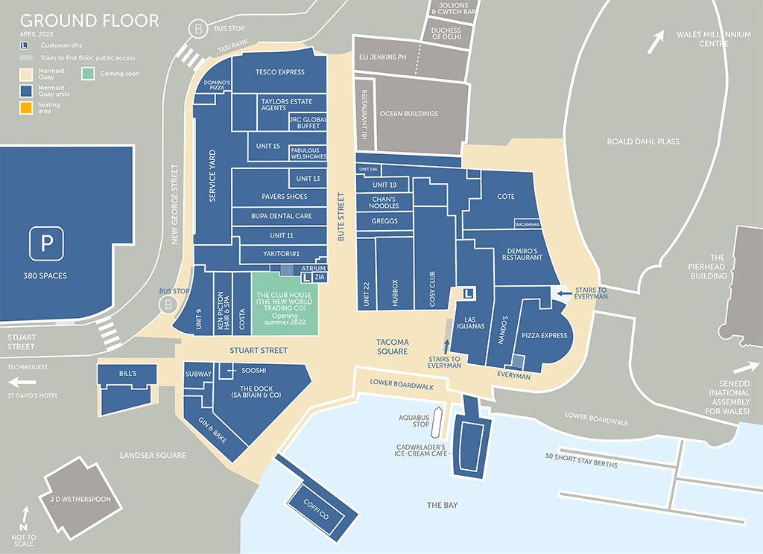 There is little way of speeding this up, as a lot of my own judgement is used and therefore I cannot have someone else help me. Twenty paces will differ from person to person too, along with what cameras are considered close enough to the stopping point for that section, so repeated examples of this data collection by different people may yield different results. My method is a systematic sampling method, with the start points selected as the far right of Mermaid Quay and the most southern point of Bute Street, as seen in Figure 13. I have chosen to do it like this as it allows me to cover the entire Quay in a logical way, meaning I can confidently say I did not forget to look at a section or miss anything I am looking for, or accidentally count features twice unknowingly. Overall, there are 15 stop points, with 9 on Transect 1, and 6 on Transect 2.

Figure - Shop map of Mermaid Quay (Mermaid Quay, n.d.) 12:01

Another limitation is that while going along my transects it is possible I will miss features not visible from my transect points, should they be tucked around obstacles or around corners I do not go down. This means no matter my confidence my results will be an average, however, I have selected my transects to cover the vast majority of key areas in Mermaid Quay so that any missed features are negligible.

While completing these transects, I will also be counting any alarm systems I can see attached to buildings. I expect to see at least one per business. As I go along my transects, I will take both a tally of what I can see, along with marking each type onto a map I have in paper in front of me to note location (Figure 17).

Following this I will replicate this map digitally and represent my counts of security features in bar charts. If I see any other features while completing my transects, I will mark these down and add them in respectively. I expect to see police officers on patrol while completing my data collection, which I will mark down as a security feature too. For this hypothesis I will also be using annotated pictures to describe the location and what security features are present. These methods are an excellent way of showing the ratio of security features relative to each other and where in the Quay they are located.

I will do this on both visit dates, Thursday 20th of October 2022 between the hours of 16:00 and 17:00 and on Saturday 19th November 2022 between the hours of 14:00 and 15:00.

Once I have this data, I will be able to look at how much security there is throughout Mermaid Quay and use my judgement to decide whether this constitutes as major Fortification in Mermaid Quay.

## Distribution of fortification is widely spread and even throughout Mermaid Quay

Landscape means “all the visible features of an area of land” [13] In the context of my research this means the entire area I am looking at. When deciding whether Mermaid Quay is a fortress landscape or not, it is crucial that the points I use to argue either way are prevalent throughout the entire Quay, not just a small area or section of. To do this I will be using two data collection techniques, a heat map and a land use survey.

My heat map will use the data collected during my transect tally, however, I will represent the data instead by grouping everything I find into “Security Features” collected on the 19th of November between 14:00 and 15:00. Then, overlaying a map of Mermaid Quay, depending on how many “Security Features” are in an approximately 8mx8m section of the Quay, the square will be given a colour, with different colours representing different amounts of features. This will cover the entire Quay and for this hypothesis to be true generally there should only be one colour throughout representing fortification all over the Quay, providing a very easy to read display of which areas have what. This provides a general overview that needs little interpretation other than referencing they key on the map, compared to bar graphs or spider diagrams. While these could be used, they are more complicated and need to be read into much more than a coloured overlay on a map. One issue with this method is I will only be able to cover the outdoor sections of the Quay where I walked, and inside of buildings or sections of the Quay I was unable to visit cannot be shown. I will represent these areas differently to areas I looked at containing no features, to make it clear what was present and where.

I completed a land use survey of Mermaid Quay (see Figures 6 and 17) the Quay on the 20th of October 2022, which is a systematic sampling survey. This was done as it was the most logical way of ensuring all buildings are looked at and included in the survey along with this being the present manner to collect this data, having been on an A-Level Geography trip at the time. This will allow me to look at what areas of Mermaid Quay are being used for what. With this, I can compare it to the heat map and say what the land where high levels of security are present are being used for. Finally, I will bring these together and look at what the distribution of fortification is, what land is being used for where security is high, to prove the hypothesis that distribution is even throughout the Quay.

# Data Representation and Analysis

Throughout my data collection a range of data has been collected. In the following pages I will be proving each of my hypotheses with this data along any analysing what it shows. Following this in my evaluation and conclusion sections I will review how my data collection went along with what my conclusion is linking back to my main question of this project.

## Map Description automatically generatedCrime in Mermaid Quay occurs prevalently

Figure - Emotion Map of Mermaid Quay (B B RESTAURANT 101, n.d.)

Figure 17 is an Emotion Map of Mermaid Quay done to look at whether people visiting Mermaid Quay were feeling the effect of prevalent crime taking place in the area. When completing my survey, I asked people to choose which one of the words - mad, scared, joyful, happy, peaceful, or sad – related the most to how they felt where they were standing. When collecting this data, I gathered responses from a wide range of people in a wide range of places. The highest responses I had were Peaceful (5 times), Happy (8 times), and Joyful (8 times). This was a result that following my visit I expected to see due to it being quite busy and a seemingly pleasant place to be. I can assume visitors were able to enjoy shopping and eating in a relaxed manner with little to no worries resulting in these results. Throughout the Quay overwhelmingly people felt positive emotions.

Once anomaly I had was one lady, I approached on Bute Street related to the word “Scared” the most, and the following question I asked everyone which was “Do you feel safe in Mermaid Quay?” she responded to with a “No”. She didn’t provide explanation to this, simply providing a direct response to the question I asked. One man also said he didn’t feel safe, however, he had previously mentioned he related to “Happy” the most. He elaborated that while the emotion he felt in Mermaid Quay was happy it didn’t necessarily make him feel safe here but made no elaboration as to what resulted in that feeling being present. From my own inferences I would say that this is simply because anything can happen in a public space, and no one can ever feel totally at ease.

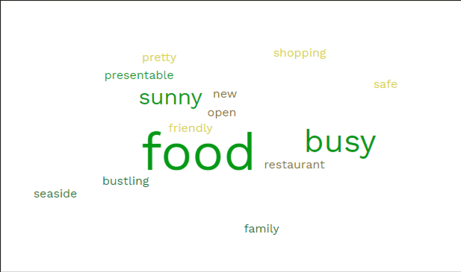

Figure - Emotion Map of Survey (Anon, n.d.)

Figure 18 is a word cloud using data also collected during my Survey, done with similar intent, a place with high rates of crime would see words relating to this topic said more commonly. Prior to the questions asked to provide data for Figure 17, I asked respondents for one word to describe Mermaid Quay. “Food”, “Busy”, and “Sunny” saw the largest results, with “Food” taking the top mark by a considerable amount. Generally, upon initially asking people would give me one or two words such as “lots of restaurants” or “very bustling, but pleasant” and when asked to narrow their phrase down into one word settled on the simpler term of “food” or “busy.

As can be seen there were a range of other responses from the people I questioned, but all of them are positive feelings towards the area. “Seaside” or “Sunny” aren’t necessarily positive feelings, instead simple observations of an area, however, the general assumption can be made that using these adjectives to describe a place has positive connotations of a pleasant place to be.

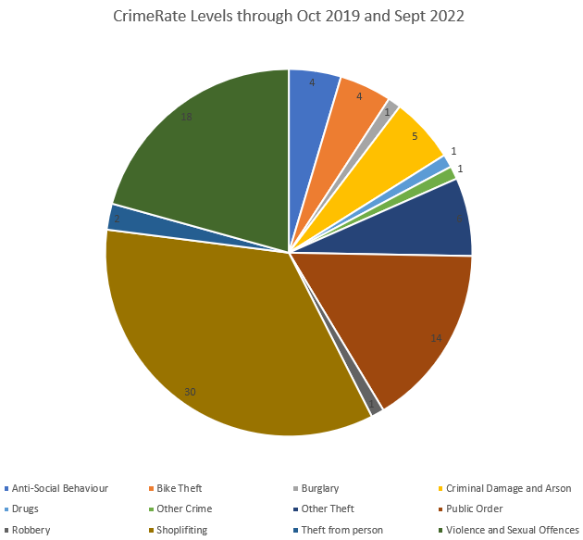

Figure – CrimeRate crime levels in Mermaid Quay from Oct 2019 to Sept 2022 (crimerate.co.uk, n.d.)

Figure 19 is a Pie Chart depicting the different crimes that took place in Mermaid Quay from October 2019 and September 2022. Using secondary data, it is a very easy way to show exactly how much crime has taken place in an area over whatever time period fits. I wanted to look at crime over a wide range and a small range of time, to remove any chances of anomaly. The data collected here is over about a year, and has come from a secondary source. It shows the bulk of crime taking place being Shoplifting, happening 30 times, which aligns with assumptions that somewhere with an abundance of shops would see this crime take place more often. It also sees a high amount of Public Order crimes (14 times) and Violence and Sexual Offences (18 times). These most probably come from evening times where individuals have gotten drunk and disorderly in public, and police have had to step in.

This time period also covers the COVID-19 Pandemic, taking place throughout 2020 and 2021 most prevalently. It can be said that some of these Public Order crimes may also come from people breaking lockdown restrictions in this area, contributing to these numbers.

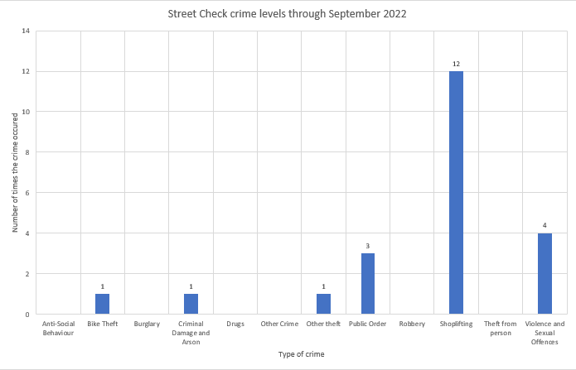

Figure - Crime levels in Mermaid Quay in September 2022 using Street Check (StreetCheck, n.d.)

Figure 20 is a bar chart showing the distribution of crimes taking place throughout the month of September in 2022. Compared to Figure 19 a much smaller range of crimes has taken place, which can be expected as it is over a lesser period of time. It is also during the winter months which, as discussed, sees less crime taking place than the summer months does and less pulic order crimes and crimes coming from outdoor activities will have occurred.

It does however match the trends of the Figure 19, with Shoplifiting taking the top spot as the highest crime taking place. At 12 occurences in this month it is logicial given the sort of businesses present here. With Violence and Sexual Offences along with Public Order taking second and third repsectectivley, again matching the trend as show above.

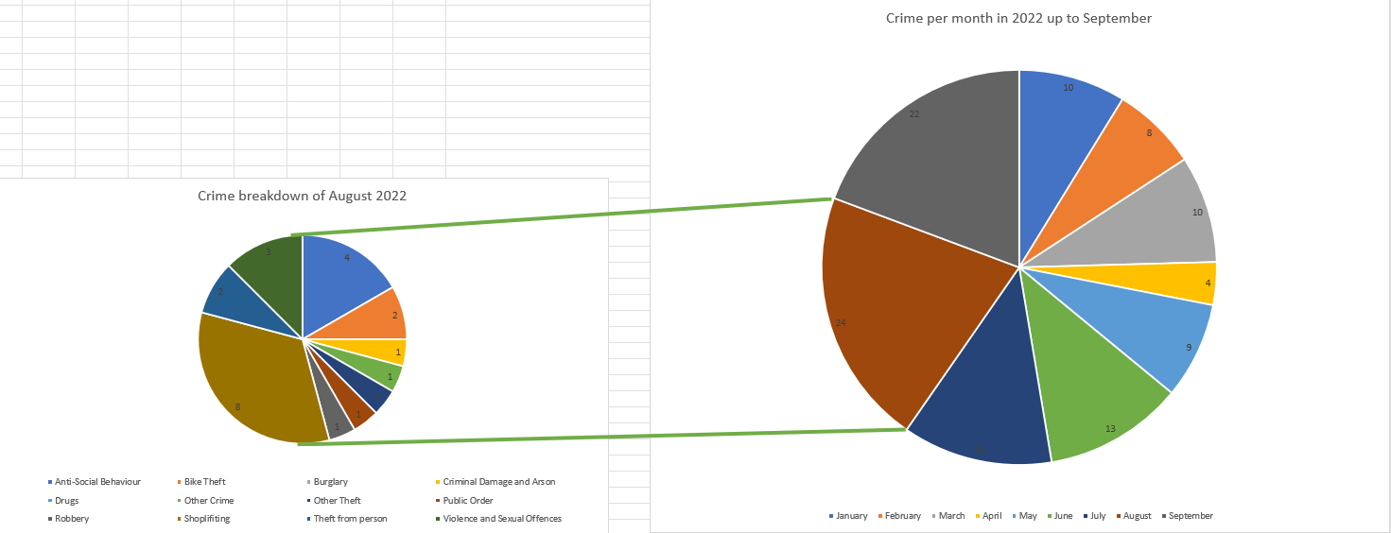Figure 21 shows a breakdown of the amount of crime taking place month by month in 2022 up until September. I have then looked at the month with the largest amount – being August – and broken down further what crimes took place. While potentially a bit repetitive it is a good way of showing that crime does not happen at even rates throughout the year, with the highest numbers being during the summer months. This will be due to increased tourism and activates taking place, bringing more people to the area.

Figure – Crime in Mermaid Quay throughout 2022 using Street Check (StreetCheck, n.d.)

In the August breakdown again, the highest number of crimes was Shoplifting happening 8 times, with Violence and Sexual Offences taking second place occurring 3 times. The difference this time being third place was Drug related crimes happening 2 times. We also see a much higher variation in the types of crimes taking place than we see in the month of September. Ten different types took place in August, a difference to the 6 which took place the month following. This fits the trend that more crime typically takes place in the summer months compared to the winter months.

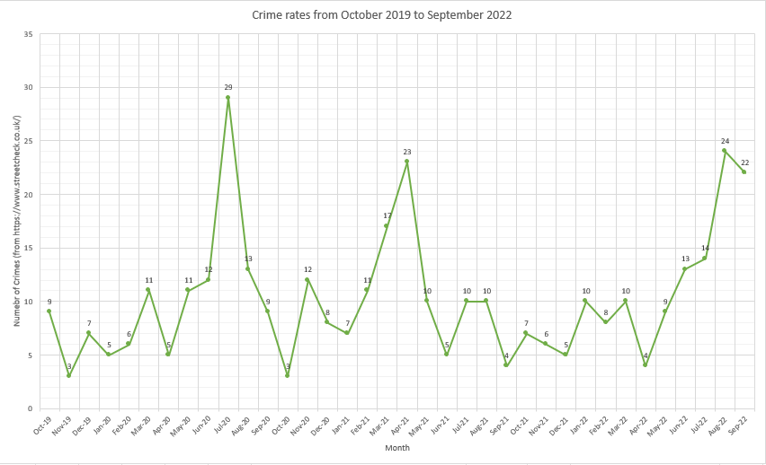Above in Figure 22 is a graph showing the different levels in crime from October 2019 to September 2022, this time using Street Check. I decided to display this differently as I feel it does better justification of how the quantity of crimes taking place changes over time, rather than just showing the proportions of crimes. Before collecting this data, I had made the assumption we would see a significantly lower rate of crime in 2020, during the COVID-19 lockdown period, however, this was not the case. Seeing 29 crimes taking place in July 2020 this is one of the top three peaks shown on the graph. We see a more expected trend during the second half of 2021, with the highest number only reaching 10. This could be down to stricter regulations during 2020 therefore normal behaviour in the area violated more crimes, which settled down once the rules were better understood.

Figure - Crime in Mermaid Quay from October 2019 to September 2022 using Street Check (StreetCheck, n.d.)

Again, it can be assumed that the summer months are seeing a higher rate of crime, not as a result of people feeling the need to commit more crimes, but rather more people being around the Quay, so the number of crimes committed are also increased.

In every month we do see the trend of peak crimes occurring during the warmer months. There was no available data for the summer months of 2019, however, it can be assumed that the trend would follow. Consistently the lowest quantities took place during the months of November through until December each year.

## A screenshot of a video game Description automatically generated with medium confidenceEvidence of major fortification of Mermaid Quay is present

Figure - Security features plotted on top of my Transect map (Mermaid Quay, n.d.) 18:19

In the map shown in Figure 23 I have plotted all the Security features I found when walking along my two transects. I printed this map out and wrote them on when I completed my data collection and then replicated this map digitally after. While the exact position of each feature may be a little off, the accuracy I was able to achieve provides a good representation of what was there.

Transect 1 had the most security features, a total of 36 features, compared to Transect 2’s 24. It had a majority of 19 external CCTV cameras, with 11 visible alarms and 6 spots where Anti-Homeless architecture was visible (a group of 3 benches all next to each other was counted as one, but two sets of three benches separated by a notable gap was counted as two). Transect 2 had significantly less external CCTV cameras, with only 7, but more visible alarms at 17. It had no examples of anti-homeless architecture. I noted that the multitude of fortress features was present along Transect 1, which was also where the majority of higher costing businesses. Higher end restaurants and bars like Hub Box or Nando’s were along this strip, whereas Transect 2 had more lower profile/less expensive shops such as Greggs or independent businesses. Transect 2 was along Bute Street, where land value is typically less, it also did not have a seafront view, lowering the value even less matching this trend. This is proved in Figure 28, a land use survey showing the majority of land was Restaurants.

As exampled in Figures 25 and 26 below, Bute Street was much more closed in compared to the seaside view providing openness along Transect 1. This will provide a more unsafe feeling when here, especially at night, as there is less visibility. Even if the blocked view doesn’t actually stop you from seeing potential threats (in this example the only thing containing the area are taller buildings on both sides, not actually blocking the view of where people can be) this will create an unsafe feeling.

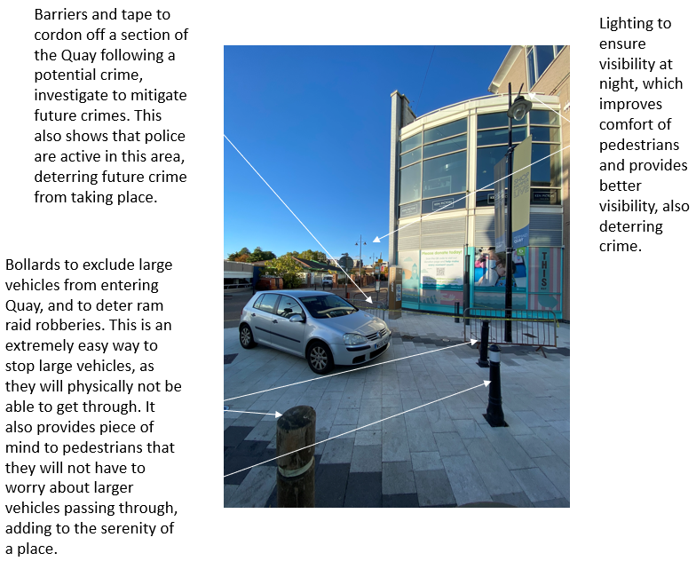

Figure - Annotated Picture at the end of Transect 1 Joshua Netherton (20th October 2022)

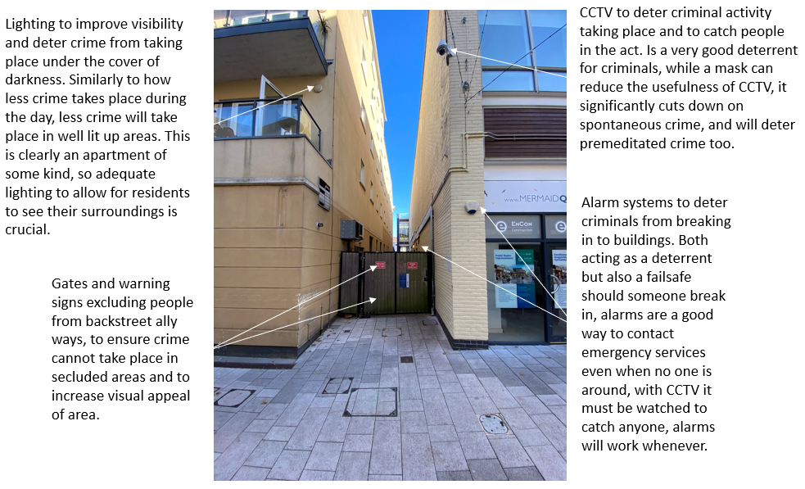

Figure - Annotated picture at point 4 along Transect 2 Joshua Netherton (20th October 2022)

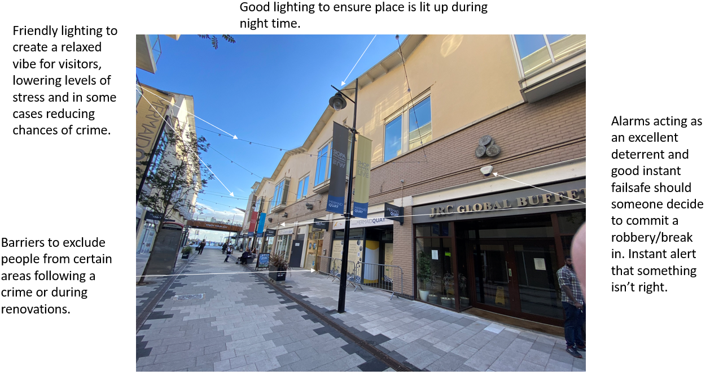

Figure - Annotated picture along Bute Street in Mermaid Quay Joshua Netherton (20th October 2022)

## A screenshot of a video game Description automatically generated with medium confidenceDistribution of fortification is widely spread and even throughout Mermaid Quay

Figure - Heat map of Security Features in Mermaid Quay (Mermaid Quay, n.d.) 18:19

This land use survey above (Figure 27) is a depiction of where security features where in a much more simplified method. Any area not represented by a colour was not counted when I collected my data and yellow squares were locations where there were no present security features. Generally, there was an even distribution of security features throughout Mermaid Quay. Once exception is about halfway along Transect 2 (the northward branch) a pocket of a number of fortifications was present. Figure 25 is a picture I took from the transect of where this pocket was, down an alleyway to the right of Bute Street, protected by a gate. Down this was a collection of alarms and cameras, protecting this secluded area from trespassers.

## A picture containing diagram Description automatically generatedLand Use Survey

Figure - Land use survey of Mermaid Quay (accounts.google.com, n.d.) 15:42

Figure 28 is a land use survey completed of Mermaid Quay to look at what the land in this area is used for. It is a good way to look at what areas are being used for and can be linked to other maps to show what type of businesses use what fortress techniques. As can be clearly see most of the business in Mermaid Quay is from food establishments. Especially on the sea front the largest units are occupied by restaurants, with smaller buildings being occupied by fast food. There are also several retailing businesses and office spaces. These provide a larger reason for local people to come and visit for work or to shop for groceries, increasing footfall.

An increase in footfall is a very passive contribution to a fortress landscape. Somewhere that encourages many people to visit excludes antisocial behaviour due to the large number of eyes watching. Mermaid Quay has many restaurants which attract people throughout the day and into the night, continuing to protect the area. Similarly, somewhere with a high footfall and many visitors will also want to fortify to continue keeping its visitors safe.

Lesser so we can also see some public service units along with a couple plots for entertainment. While it wouldn’t be expected to see land dedicated to public services here, I was surprised to find that a very small number of entertainment facilities were present, expecting to see more to attract people not looking to eat.

# Conclusion

## Hypothesis Breakdown

### Crime in Mermaid Quay occurs prevalently.

Using the data, I have collected, I have concluded that crime does occur in Mermaid Quay, but maybe not to the extent that I previously believed that it would. Looking at secondary data, it is clear that year-round crime is taking place. Figure 22 shows that in the past three years there hasn’t been a single month of no crime. While some have been low there has consistently been something happening. Some months saw certain types of crime not taking place with shoplifting typically taking the top spot.

When breaking down the timeframes further it was clear that the summer months saw the largest amounts of crime. The top scoring month was not consistent each year, but it was always a late summer month in the range of June to August. The only exception to this was in 2021, where April saw the year high of 23.

Looking at this data alone would lead anyone to believe that this hypothesis is completely true, however, alongside this I also completed a survey. This was designed to also look at the live feed of how people felt in this area. Following the analysis of this data, I can conclude that people present in Mermaid Quay do not feel that crime does not occur prevalently. I asked unbiased questions designed in such a way to achieve honest responses, and generally got feedback painting Mermaid Quay as somewhere that doesn’t see an abundance of crime.

Therefore, yes, crime does occur in Mermaid Quay – this is undeniable. While the websites used were good, it is likely that some numbers carried over from surrounding areas, renowned for their high rates of crime. However, not to the extent previously assumed.

### Evidence of major fortification of Mermaid Quay is present.

Following the collection of my primary data, I have come to the conclusion that absolutely, yes, there is evidence of major fortification having taken place in Mermaid Quay. Looking at my annotated pictures they provide a good breakdown of snippets of the Quay, showing what was present. From what I found too; this was not exclusive to these points either. The options for the photos I could use was not limited, and CCTV systems, alarms, lighting, and anti-homeless architecture was all present in abundance in Mermaid Quay. While coming from this area feeling the need to fortify for safety, fortress features are growing ever more common in modern day urbanisation. The growth of cities are coming with more CCTV, alarms, among other fortress features to deter crime before it is ever able to begin.

As can be shown in Figure 23 I found more deterrent features along Transect 1 and more alarm systems and active prevention methods along Transect 2. Transect 2 was along Bute Street, Bute Town is renowned for its crime so it is expected that more active methods would be used in this area. Alarms act as an instant warning if unwanted guests are present on a business’s grounds. CCTV only serves its purpose if watched constantly or if the footage is asked for following a crime, and therefore is a good way to ward off criminals but can take longer to do its job.

So, in conclusion, evidence of major fortification is present in Mermaid Quay.

### Distribution of fortification is widely spread and even throughout Mermaid Quay.

Once I had plotted my points of fortress features around the quay, I produced a heatmap of the two transects I walked, seen in Figure 27. This displays where there are features and gives a range of how many in each square. Overwhelmingly distribution of features was even throughout the Quay and spread widely across it.

Looking at the diagram, there is more yellow than any other colour, but that is because it would be near impossible to include some means of fortification in every square inch of a place without it practically becoming Fort Knox, which for this use case is unpractical and would exclude nearly everyone, not just the criminals.

Some areas of Mermaid Quay did see a little more fortification than others, with a couple orange squares in certain pockets of the Quay, but these anomalies are not spread enough to discount this hypothesis. Given Mermaid Quay is more of a group that leases the land it owns, it was always likely this hypothesis was true given no company would only fortify small sections of their land, rather cover the area as a whole.

To end, using the features I found and their location, the distribution of fortification is widely spread and even throughout the entire Quay.

### To what extent is Mermaid Quay a Fortress Landscape?

Having had all three of my hypothesises be correct, that can only lead me to saying that to a full extent is Mermaid Quay an example of a Fortress Landscape, designed with the intent of security and exclusion, but not so much that it can remain as a functioning tourist hot spot where business can thrive.

Compared to some other examples of Fortress Landscapes, such as military zones or prisons, one could argue that Mermaid Quay barely compares. However, it is important to remember what a Fortress landscape is defined as, which is somewhere “deliberately landscaped and designed around security, protection, surveillance and exclusion.”[14] While some places may have more of these features than others, a Boeing 747, and a Cessna 172, despite their major differences in size, capacity, range, and engineering, are both – to a full extent – a plane.

Henceforth, my final conclusion of this research project is that to a full extent Mermaid Quay is an example of a Fortress Landscape.

# Evaluation

Having completed my study, I am now able to overview any issues I have had with my research and data collection, along with if my result is accurate and can be used as a decider, or whether I have come to a flawed conclusion.

Firstly, it is important to look at the reliability of the data I have collected and used. You can use any data to come to any conclusion, it is important that the data I have been using has provided me with an accurate conclusion. For my secondary data I have used a few websites, this was done with the purpose of being able to cross reference my findings to ensure the values I was using were correct. Originally, I had planned on using three separate websites to collect this data, but upon cross referencing the values, I found that CrimeRate was unreliable and provided me with incorrect data. While a good way to collect a comparative overview of crime in a place, I required exact crime statistics, something it was unable to give.

I was the sole collector of my primary data. I completed my first tally in October while on a school trip designed to help us begin planning what methods we would use to collect our different data. While here I also completed my land use survey. Once I got back from this trip, I realised that it provided more use in figuring out what I needed, rather than giving me data I could use. So, I returned to Mermaid Quay in November with an exact plan of what I needed to leave with. This also allowed me to cross check some of the data I gather on my first trip, improving its accuracy. As a result of this I am happy that my primary data was reliable in the sense that I didn’t see an anomalous result on either of the days I went, considering the data I was collecting was static and isn’t something subject to major changed in the short term.

In the beginning I had some trouble deciding on what exact area I would look at to determine if Mermaid Quay was a Fortress Landscape, originally looking at my local area as my study, then changing to Mermaid Quay on the coursework trip I attended. If I were to do this study again, I may look at comparing Mermaid Quay to another place in Cardiff Bay / Cardiff to see whether Mermaid Quay is more or less fortified than other places local to it. I would also look at more reasons as to why Mermaid Quay has forfitied, looking at places nearby and their own crime rates to decide as to whether the Quay’s fortification was justified or overkill.

With this being said, I still believe that my conclusion is valid. Using the data I have collected, one could argue it provides a subjective view on my result. Only using crime statistics and evidence from the Quay, to see if the Quay possesses a certain trait. The values I have given provided undeniable conclusions outlined in my conclusion section.

Finally, I came across a few limitations during my project. Firstly, I was looking at whether major fortification has taken place in Mermaid Quay. I did not compare the results I have gathered to Mermaid Quay in its past, and for fortification to have taken place there would need to have been a time where there were less fortress features present in Mermaid Quay. However, I had a hard time finding any way to provide this data without having started this project years ago. As a result of this I decided that fortification has to have taken place at somepoint, even if that fortification was the construction of Mermaid Quay itself, taking a rundown area and building a shopping area is an example of exclusion of poorer people, therefore, fortification.

As mentioned, Crime Rate was to be one of my main sources of secondary data, however, after cross referencing the information it provided, I found it to be incorrect, and so have not used it as such and influential aspect of my representation. I still included a pie chart with the data it gave, as the proportions of crime it showcases match the trends I found, however, the values themselves seemed to be much less than what they should be.

During my data representation I also came across a couple of issues. Originally, I had planned on using many more pie charts in the first section to display my first hypothesis. I thought that they would be a good way of both showing then number of different crimes taking place, along with the proportion of what was happening. However, after doing the first couple I came across a couple issues. The first being it was a very repetitive method of data representation, they all looked very similar and without reading the information about it, distinguishing what was going on was tricky. The second issue I had was it not being overall very good for the data I am displaying. It is tough to read what colours are what, and other than the largest segments the eye tends to completely ignore the smaller parts. This isn’t what I am trying to do, I want to showcase what is there, and in the text look at the bigger sections.

To combat this, I decided to significantly diversify the data representation I used for my secondary data. Using both a bar graph and a scatter graph I found both of these to be exceedingly better at serving the purpose I had, and while continuing to show a good comparison, also displayed the different features and levels much better.

Along with this, as can be inferred from my transects and seen in my heat map I was unable to cover the entire area of Mermaid Quay, I focused on the inner areas and there was no coverage of the outer sections. This is a limitation of the study and should I have included them in my study area the results I collected may have differed. I would hypothesize that the values I got would only increase I proportion to what I have, and no major anomalies would arise, however, this is only an inference. Should I do this study again I would cover a larger area of the Quay and go for longer times over more days, to collect a wider range of results, covering weekdays and weekends, during the day and during the evening.

I also covered none of the insides of the buildings in the area, while not necessary there would be a collection of fortress features inside the local businesses, contributing to my study further. This is something I may consider doing should I do this project again.

Overall, my data has linked back to the theory outlined in my introduction defining Mermaid Quay to a fortress landscape. The data collected shows that even family friendly foot and shopping areas have felt the need to fortify to protect its landscape. This link back to geographical thinking is how I’m able to measure my project as a success, as it contributes to the geographical world. The data I did collect is strong and, removing the mentioned secondary data, it gave me results I found to be valid and correct. I was as unbiased as I feel I could’ve been with the collection of my data and managed to cover a large array of features without missing many.

# Table of Figures

Figure 1 - Map of Mermaid Quay (Google Maps. n.d.) 10:11 0

Figure 2 - Sky view of fortress (Atlas Obscura, n.d.) 10:01 2

Figure 3 - Anti-homeless architecture (Andreou, 2015) 10:52 3

Figure 4 - Anti-homeless architecture in Mermaid Quay (Netherton, 2022a) 3

Figure 5 - Highlight of Mermaid Quay (Mermaid Quay · Cardiff CF10 5BZ, UK, n.d.) 11:04 4

Figure 6 - Map of Cardiff (Mermaid Quay · Cardiff CF10 5BZ, UK, n.d.) 11:04 4

Figure 7 - Map of United Kingdom (Google Maps, n.d.) 11:15 4

Figure 8 - Place map for Cardiff (Cardiff · United Kingdom, n.d.) 12:46 5

Figure 9 - Cardiff Bay (Kieren, n.d.) 11:50 5

Figure 10 - Fortress example (Eaglescliffe, 2014) 13:14 5

Figure 11 - CCTV Features in Mermaid Quay (Netherton, 2022b) 6

Figure 12 - Uneven development in São Paulo (Catling, 2015) 11:06 7

Figure 13 - (www.arcgis.com, n.d.) 18:19 8

Figure 14 - Risk Assessment 9

Figure 15 - CrimeRate map (crimerate.co.uk, n.d.) 16:03 9

Figure 16 - Shop map of Mermaid Quay (Mermaid Quay, n.d.) 12:01 11

Figure 17 - Emotion Map of Mermaid Quay (B B RESTAURANT 101, n.d.) 13

Figure 18 - Emotion Map of Survey (Anon, n.d.) 14

Figure 19 – CrimeRate crime levels in Mermaid Quay from Oct 2019 to Sept 2022 (crimerate.co.uk, n.d.) 15

Figure 20 - Crime levels in Mermaid Quay in September 2022 using Street Check (StreetCheck, n.d.) 16

Figure 21 – Crime in Mermaid Quay throughout 2022 using Street Check (StreetCheck, n.d.) 17

Figure 22 - Crime in Mermaid Quay from October 2019 to September 2022 using Street Check (StreetCheck, n.d.) 18

Figure 23 - Security features plotted on top of my Transect map (Mermaid Quay, n.d.) 18:19 19

Figure 24 - Annotated Picture at the end of Transect 1 Joshua Netherton (20th October 2022) 20

Figure 25 - Annotated picture at point 4 along Transect 2 Joshua Netherton (20th October 2022) 20

Figure 26 - Annotated picture along Bute Street in Mermaid Quay Joshua Netherton (20th October 2022) 21

Figure 27 - Heat map of Security Features in Mermaid Quay (Mermaid Quay, n.d.) 18:19 21

Figure 28 - Land use survey of Mermaid Quay (accounts.google.com, n.d.) 15:42 22

# Bibliography

accounts.google.com. (n.d.). *Sign in - Google Accounts*. [online] Available at: https://www.google.com/maps/d/u/0/edit?mid=1xtYC9gHrQjwSAQiqnQJyNXMTQdiUMqI&ll=51.46365159945957%2C-3.165598286098854&z=18 [Accessed 24 Nov. 2022].

Andreou, A. (2015). *Defensive architecture: keeping poverty unseen and deflecting our guilt*. [online] the Guardian. Available at: https://www.theguardian.com/society/2015/feb/18/defensive-architecture-keeps-poverty-undeen-and-makes-us-more-hostile [Accessed 3 Nov. 2022].

Anon, (n.d.). *Free Word Cloud Generator*. [online] Available at: freeworldcloudgenerator.com/generatewordcloud [Accessed 29 Nov. 2022].

Atlas Obscura. (n.d.). *Star-Shaped Walls of Almeida*. [online] Available at: https://www.atlasobscura.com/places/fortress-of-almeida [Accessed 3 Nov. 2022].

B B RESTAURANT 101. (n.d.). [online] Available at: https://www.mermaidquay.co.uk/website/wp-content/uploads/2022/06/MQ-Ground-Floor-June-22.pdf [Accessed 29 Nov. 2022].

calmview.cardiff.gov.uk. (n.d.). *Search Results*. [online] Available at: http://calmview.cardiff.gov.uk/Record.aspx?src=CalmView.Catalog&id=DCBDC#:~:text=CBDC%20was%20an%20organisation%20established [Accessed 11 Nov. 2022].

Cardiff · United Kingdom. (n.d.). *Cardiff · United Kingdom*. [online] Available at: https://www.google.co.uk/maps/place/Cardiff/@51.5517743,-3.7323955,9z/data=!4m5!3m4!1s0x486e02d434ec53f5:0x143406db6586670e!8m2!3d51.483707!4d-3.1680962 [Accessed 4 Nov. 2022].

Catling, C.S. (2015). *Uneven growth: tactical urbanism for expanding megacities*. [online] Architectural Review. Available at: https://www.architectural-review.com/essays/exhibitions/uneven-growth-tactical-urbanism-for-expanding-megacities [Accessed 9 Nov. 2022].

Caught on Camera. (2016). *5 Benefits of Installing CCTV in Your Home*. [online] Available at: https://www.caughtoncamera.net/news/5-benefits-installing-cctv-home/#:~:text=Visual%20crime%20deterrent [Accessed 17 Nov. 2022].

crimerate.co.uk. (n.d.). *Cardiff Crime and Safety Statistics*. [online] Available at: https://crimerate.co.uk/south-glamorgan/cardiff [Accessed 16 Nov. 2022].

crimerate.co.uk. (n.d.). *Crime Map with Interactive Offence Types | CrimeRate*. [online] Available at: https://crimerate.co.uk/crime-map [Accessed 16 Nov. 2022].

Eaglescliffe, B. (2014). *Medieval Castles Were Smelly, Damp, and Dark*. [online] Owlcation. Available at: https://owlcation.com/humanities/What-Life-Was-Like-in-a-Medieval-Castle-Middle-Ages [Accessed 8 Nov. 2022].

Geraghty, L. (2022). *5 ways anti-homeless architecture is used to exclude people from public spaces*. [online] The Big Issue. Available at: https://www.bigissue.com/news/housing/anti-homeless-architecture-hostile-designs/#:~:text=There%20are%20many%20names%20for [Accessed 3 Nov. 2022].

Google Maps. (n.d.). *Google Maps*. [online] Available at: https://www.google.co.uk/maps/@51.4819126,-3.1767277 [Accessed 4 Nov. 2022].

Google Maps. (n.d.). *Google Maps*. [online] Available at: https://www.google.co.uk/maps/@54.4861569,-7.1862054,6z [Accessed 4 Nov. 2022].

Kelsey, C. (2018). *Cardiff Bay: Success and failure in Welsh history’s biggest regeneration*. [online] WalesOnline. Available at: https://www.walesonline.co.uk/business/business-news/grand-promises-cardiff-bay-success-14070156#:~:text=That%20name%20is%20a%20legacy [Accessed 4 Nov. 2022].

Kieren (n.d.). *12 Best Things To Do In Cardiff Bay [2022 Guide]*. [online] Wales Guidebook. Available at: https://walesguidebook.com/things-to-do/south-wales/cardiff/cardiff-bay/ [Accessed 11 Nov. 2022].

Mermaid Quay · Cardiff CF10 5BZ, UK. (n.d.). *Mermaid Quay · Cardiff CF10 5BZ, UK*. [online] Available at: https://www.google.co.uk/maps/place/Mermaid+Quay,+Cardiff/@51.4635816,-3.1680653,534m/data=!3m2!1e3!4b1!4m5!3m4!1s0x486e0337c76d4031:0xf94e95c4c6431b7a!8m2!3d51.4635816!4d-3.1658766 [Accessed 1 Nov. 2022].

Mermaid Quay · Cardiff CF10 5BZ, UK. (n.d.). *Mermaid Quay · Cardiff CF10 5BZ, UK*. [online] Available at: https://www.google.co.uk/maps/place/Mermaid+Quay,+Cardiff/@51.4640905,-3.168601,16.11z/data=!4m5!3m4!1s0x486e0337c76d4031:0xf94e95c4c6431b7a!8m2!3d51.4635816!4d-3.1658766 [Accessed 4 Nov. 2022].

Mermaid Quay. (n.d.). *History of Mermaid Quay*. [online] Available at: https://www.mermaidquay.co.uk/history-of-mermaid-quay/ [Accessed 8 Nov. 2022].

Mermaid Quay. (n.d.). *Mermaid Quay*. [online] Available at: https://www.mermaidquay.co.uk/leasing-opportunities/ [Accessed 17 Nov. 2022].

Netherton, J. (2022a). *Anti-Homeless Architecture in Mermaid Quay*.

Netherton, J. (2022b). *CCTV Features in Mermaid Quay*.

Oxfordlearnersdictionaries.com. (2022). *urban-development-corporation - Definition, pictures, pronunciation and usage notes | Oxford Advanced Learner’s Dictionary at OxfordLearnersDictionaries.com*. [online] Available at: https://www.oxfordlearnersdictionaries.com/definition/english/urban-development-corporation [Accessed 11 Nov. 2022].

StreetCheck (n.d.). *Local Crime Information for Mermaid Quay, Cardiff, Wales, CF10 5BZ - October 2022*. [online] StreetCheck. Available at: https://www.streetcheck.co.uk/crime/cf105bz [Accessed 16 Nov. 2022].

Strouf, J.L.H. (2009). *The literature teacher’s book of lists*. San Francisco, Ca: Jossey-Bass.

Sunley, P. (2017). *Structural Transformation, Adaptability and City Economic Evolutions Case Study Report BRISTOL*. [online] Available at: https://www.cityevolutions.org.uk/wp-content/uploads/171127-Working-Paper-7-Bristol-Case-Study-Report.pdf [Accessed 4 Nov. 2022].

Wikipedia Contributors (2019). *Landscape*. [online] Wikipedia. Available at: https://en.wikipedia.org/wiki/Landscape [Accessed 17 Nov. 2022].

www.arcgis.com. (n.d.). *Map Viewer*. [online] Available at: https://www.arcgis.com/apps/mapviewer/index.html [Accessed 15 Nov. 2022].

www.coolgeography.co.uk. (n.d.). *New urban landscapes*. [online] Available at: https://www.coolgeography.co.uk/advanced/New_urban_landscapes.php#:~:text=Fortress%20landscapes&text=Developments%20are%20deliberately%20landscaped%20and [Accessed 3 Nov. 2022].

1. (www.coolgeography.co.uk, n.d.) 10:20
2. (Geraghty, 2022) 10:53
3. (www.coolgeography.co.uk, n.d.) 14:47
4. (Sunley, 2017) 11:10
5. (Kelsey, 2018) 12:34
6. (Oxfordlearnersdictionaries.com, 2022) 11:49
7. (calmview.cardiff.gov.uk, n.d.) 12:25
8. (Mermaid Quay, n.d.) 13:22
9. (Strouf, 2009) 11:24
10. (StreetCheck, n.d.) 15:44
11. (crimerate.co.uk, n.d.) 15:45
12. (Caught on Camera, 2016) 11:43
13. (Wikipedia Contributors, 2019) 12:25
14. (www.coolgeography.co.uk, n.d.) 13:30